**P510/****2**

**PHYSICS**

Paper 2

Jul/ Aug 2016

2 ½ hours



**MUKONO EXAMINATIONS COUNCIL**

Uganda Advanced Certificate of Education

PHYSICS

Paper 2

2 hours 30 minutes

**INSTRUCTIONS TO CANDIDATES**

* *Answer* ***five*** *questions, including at least* ***one*** *from each section, but* ***not more*** *than* ***one*** *from any of the sections A and B.*
* *Where necessary assume the following constants:*
* *Acceleration due to gravity, g = 9.81ms-2*
* *Speed of light in vacuum, c = 3.0 x 108ms-1*
* *Speed of sound in air v = 340ms-1*
* *Electronic Charge, e = 1.6 x 10-19C*
* *Electronic mass, me = 9.1 x 10-31kg*
* *Permeability of free space, μ0 = 4.0π x 10-7Hm-1*
* *Permittivity of free space, ε0 = 8.85 x 10-12 Fm-1*
* *The Constant, = 9.0 x 109F-1m*

**SECTION A**

1(a) What is refraction of light? ***(1mark)***

(b)

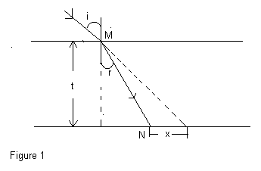

Figure 1 above shows a ray of light from air incident on a parallel sided glass block of thickness t at M, at an angle, I, and is refracted through angle, r, to pass through N,

(i) List three factors that determine the lateral displacement, x. ***(2marks)***

(ii) Show that

$\frac{x}{t}$ = tan i – tan r. ***(3marks)***

(c)

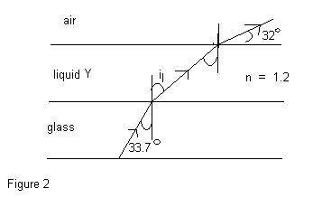

Figure 2, shows a ray of monochromatic light from glass, passing through liquid Y, and emerging into air. If the refractive index of Y is 1·2, and the ray emerges as shown, find

(i) The refractive index of the glass. ***(2marks)***

(ii) The deviation due to refraction at the glass-liquid interface. ***(3marks)***

(d) Describe how the refractive index of a material of glass prism of known refracting

angle can be obtained using a spectrometer. ***(6marks)***

(e) A piece of stone at the bottom of a water- tank viewed from directly above the water

appears displaced by 0·2m. If the refractive index of water is 1·33, find the depth of

water in the tank. ***(3marks)***

2. (a) (i) Draw a ray diagram to show how a convex mirror forms an image of a real object.

***(2marks)***

(ii) Describe how you could determine the focal length of a convex mirror using a

convex lens.  ***(5marks)***

(b) An object is placed at a distance, d, on one side of the principle focus, F, of a convex

lens of focal length f. The image is formed at some point C. Show that when the

object is displaced to a point distance, d, on the opposite side of, F, the image gets

displaced by distance $\frac{{2f}^{2}}{d}$. ***(4marks)***

(c) The objective and eye piece of an astronomical telescope have focal lengths of

95cm and 5cm respectively. Find the:

(i) Separation of the two lenses when the final image is formed at 150cm a from the eye

Piece. ***(4marks)***

(ii) Position of the eye ring. ***(2marks)***

(d) (i) What is the significance of the eye ring of an astronomical telescope? ***(2marks)***

(ii) State two advantages of a reflecting telescope over a refracting telescope. ***(1marks)***

3(a) (i) What is meant by the terms free and damped oscillations? ***(3marks)***

(ii) Describe how a forced oscillation can build up into large energy oscillation.

***(3marks)***

(b) (i) Describe how you can determine the velocity of sound in air using a glass tube and

a single turning fork. ***(5marks)***

(ii)From the experimental values in b (i) above deduce the expression for the end

correction of the glass tube. ***(2marks)***

(c) (i) What is meant by beats? ***(1mark)***

(ii) Calculate the frequency of beats heard by a stationary observer when a source of

sound of frequency 69Hz is receding with a speed of 7· $0{ms}^{-1}$ towards a vertical

wall. ***(5marks)***

(iii) State two uses of beats. ***(2marks)***

4(a) (i) State the conditions necessary for formation of observable interference due to two

waves. ***(2marks)***

(ii) Explain why an oil film on a water surface appears to be coloured. ***(4marks)***

(b) In young’s double slit experiment, the apparatus are set up to produce interference

fringes on the screen. Explain how the following adjustments improve the accuracy

of measurement of fringe widths.

(i) Moving the source slit closer to the secondary slits. ***(2marks)***

(ii) Moving the screen further away from the secondary slits. ***(2marks)***

(iii) Replacing double coloured light with monochromatic light. ***(2marks)***

(c) Two glass slides in contact at one end are separated by a sheet of paper 15cm from

the line of contact to form an air wedge. When the air wedge is illuminated normally

by light of wave length 5 $·8$ x ${10}^{-7}$ m, interference fringes of separation 1·6mm are

found in reflection. Find the thickness of the paper. ***(4marks)***

(d) State two uses of interference. ***(2marks)***

**SECTION B**

5. (a) Define the terms magnetic flux and magnetic flux density. ***(2marks)***

(b) A straight wire of length 30cm and resistance 0·36Ω lies at right angles to a magnetic

field of flux density 0·45T. The wire moves when a p.d of 2·0V is applied across its

ends. Calculate the:

(i) Initial force on the wire. ***(2marks)***

(ii) Force on the wire when it moves at a speed of 12 ${ms}^{-1}$. ***(4marks)***

(iii) Maximum speed attained by the wire. ***(2marks)***

(c) (i) Using an illustrative diagram, explain why a current carrying conductor in a

magnetic field experiences a force. ***(4marks)***

(ii) Draw a magnetic field pattern for two current carrying wires experiencing attractive

force. ***(1marks)***

(d) Describe with the aid of a diagram an absolute method of determining resistance.

***(1mark)***

6. (a) (i) What is meant by mutual induction? ***(1mark)***

(ii) Name one device whose action is based on mutual induction. ***(1mark)***

(b) Describe an experiment to demonstrate mutual induction. ***(3marks)***

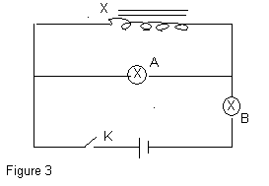

Two identical bulbs A and B are connected to an inductor, X, of large inductance as shown in Figure 3 above. Explain what is observed when,

(i) Switch K is first closed. ***(4marks)***

(ii) Switch K is opened.  ***(2marks)***

(d) A flat circulator coil of 600 turns, each of radius 8cm is rotated at a frequency of 180

revolutions per minute about an axis along its diameter, at right angles to a uniform

magnetic field of flux density 0·22T. Calculate the;

(i) e.m.f induced in the plane when the plane of the coil makes an angle of 30˚ with the

magnetic field. ***(3marks)***

(ii) r.m.s current which flows in the circuit if a resistor of resistance 3Ω is connected

across the coil. ***(3marks)***

(e) With the aid of a circuit diagram describe how a full wave rectifier works. ***(3marks)***

7(a) Define impedance of a circuit and state its unit. ***(2marks)***

(b) (i) When an a.c. voltage source is connected across a capacitor of capacitance, C, a

current of I=I0sin2πft flows in the circuit. Derive the expression for the reactance of

the capacitor. ***(4marks)***

(ii) Explain why a capacitor is considered a wattless device. ***(3marks)***

(c)

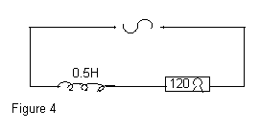

An inductor of inductance O·5Hz in series with a resistor of resistance 120Ω are

connected across an a.c. voltage source of 220V, and frequency 50Hz. Find the:

(i) Power dissipated in the circuit. ***(4marks)***

(ii) Phase angle by which voltage leads current in the circuit*.* ***(2marks)***

(d) With the aid of a diagram describe how a repulsion type of moving ammeter works.

***(5marks)***

**SECTION C**

8. (a) Define one coulomb, and one volt.  ***(2marks)***

(b) (i) Derive the expression for the electrical energy dissipated in a resistor of resistance,

R ohms carrying current, I, amperes, for t, seconds. ***(3marks)***

(ii) A network of resistors of 3Ω, 4Ω, 5Ω and 6Ω are connected with batteries of 15V

and 12V as Figure 5 below.

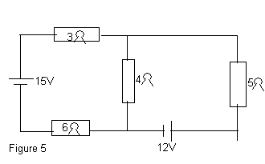

Find the

(i) Current passing through the 5Ω resistor. ***(4marks)***

(ii) Power dissipated in the 3 $Ω$ resistor. ***(2marks)***

(c) Describe an experiment to determine the dependence of resistance on the area of

cross-section of a conductor. ***(5marks)***

(d) A coil of wire has resistance of 51·2Ω at 30˚C and 52·4Ω at 80˚C. Calculate the

temperature co-efficiency of resistance of the coil. ***(4marks)***

9. (a) (i) State the coulombs law of electrostatics. ***(1mark)***

(ii) Define electric field intensity. ***(1mark)***

(b)

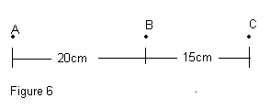

Figure 6 shows three points ABC in a straight line with a charge of +22·4µC placed at A. Find the charge which when placed at B, makes C a neutral point. ***(3marks)***

(c) (i) What is meant by corona discharge? ***(3marks)***

(ii) Explain how a body may be charged and it remains at zero potential. ***(3marks)***

(d) Derive the relationship between the electric field intensity, E, and the potential, V,

between two points in an electric field. ***(4marks)***

(e)

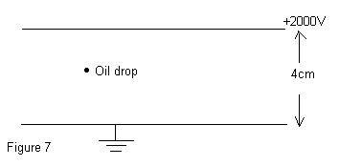

Figure 7 shows two metal plates, 4·0cm apart. The upper one is maintained at 2000V while the lower is earthed. A charged oil drop of mass 7·3 x ${10}^{-15}$ kg is introduced between the plates, and it remains stationary. Find

(i) The number of electrons attached to it. ***(3marks)***

(ii) The acceleration of the drop when the potential is suddenly reversed. ***(2marks)***

10(a) Define (i) Capacitance of a capacitor. ***(1mark)***

(ii) Relative permittivity. ***(1mark)***

(b) Describe an experiment to determine the relative permittivity of a material given

using a capacitor and a ballistic galvanometer. ***(4marks)***

(c) Show that two identical capacitors connected in parallel across a voltage source store

eight times the amount of energy they would store, if they were in series. ***(3marks)***

(d) Explain how the dielectric placed between the plates of a capacitor increases the

capacitance. ***(4marks)***

(e)

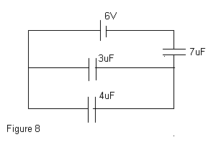

Figure 8 shows a network of three capacitors, of 3µF, 4µF and 7µF connected to a 6V battery. Find the

(i) Charge stored in the 4µF capacitor. ***(5marks)***

(ii) Energy stored in the 7µF capacitor. ***(2marks)***

***End -***